Prometheus

Prometheus is an open-source monitoring and alerting toolkit that serves as the most popular data source for Grafana. While Grafana is the "face" (visualization), Prometheus is the "engine" that collects and stores the raw data

How They Work Together
Prometheus and Grafana are often called the "perfect combo" for system observability.
- Collection: Prometheus uses a pull-based model to "scrape" numerical metrics—like CPU usage, memory, or request counts—from your applications and servers.
- Storage: It saves this information as time-series data, meaning every piece of data is stored with a specific timestamp to show how it changes over time.
- Visualization: Grafana connects to Prometheus and uses a specific language called PromQL (Prometheus Query Language) to pull that data and turn it into the graphs you see on your dashboard.

Key Components
- Prometheus Server: The core part that handles data retrieval, storage, and processing.
- Exporters: Small programs that translate existing system data (like Linux or MySQL stats) into a format Prometheus understands.
- Alertmanager: Works with Prometheus to send out notifications (like Slack or email) when something breaks, which can then be visualized in your Grafana alerts.
Why People Use It
It is the industry standard for monitoring Kubernetes and cloud-native environments because it can automatically discover new services as they are added.

You can easily get started by connecting your existing Prometheus server to Grafana under the section in the sidebar.
How to install
sudo apt update
sudo apt install prometheus prometheus-node-exporter
sudo systemctl enable --now prometheus
sudo systemctl enable --now prometheus-node-exporter
http://localhost:9090
sudo useradd --no-create-home --shell /bin/false Prometheus
yaml

global:
scrape_interval: 15s
evaluation_interval: 15s
# The path must be writable by the 'prometheus' user
query_log_file: /var/log/prometheus/query.log

scrape_configs:
- job_name: 'prometheus'
static_configs:
- targets: ['localhost:9090']
Import id 1860

How to link Grafana
http://localhost:3000
open mean list
go to add connect

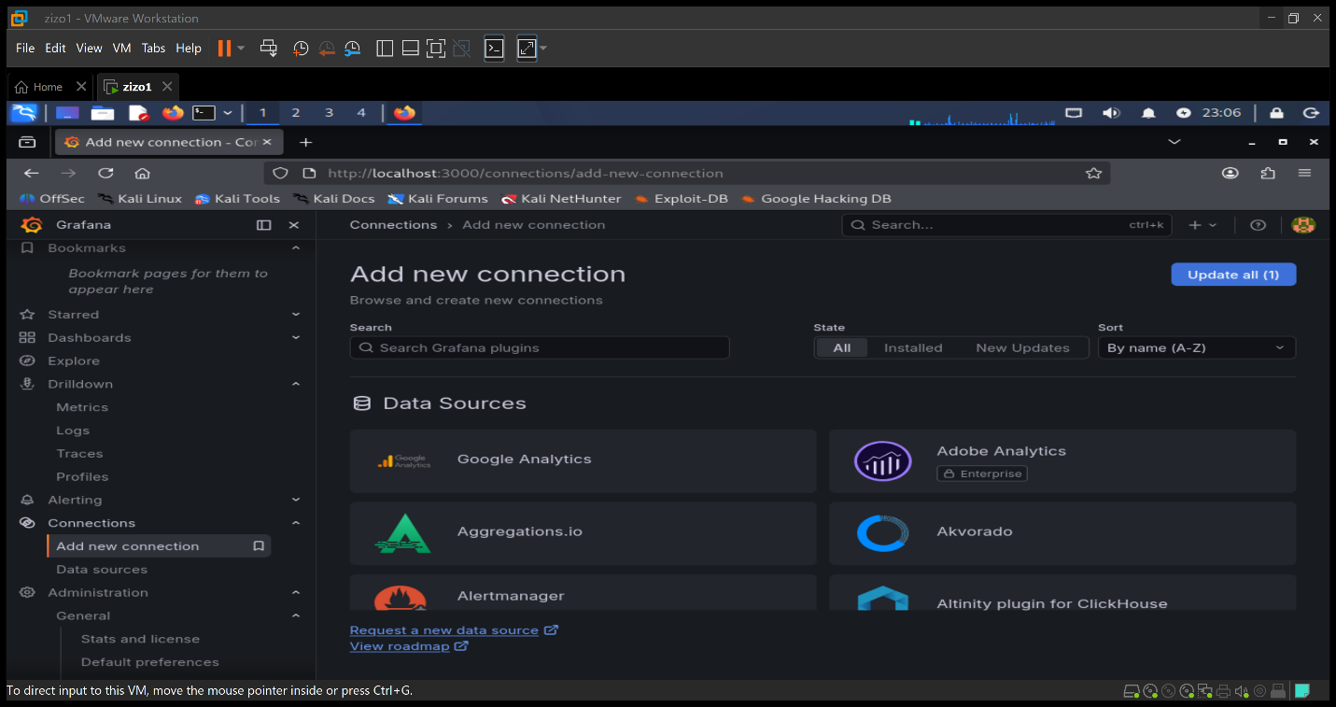

Search for Prometheus

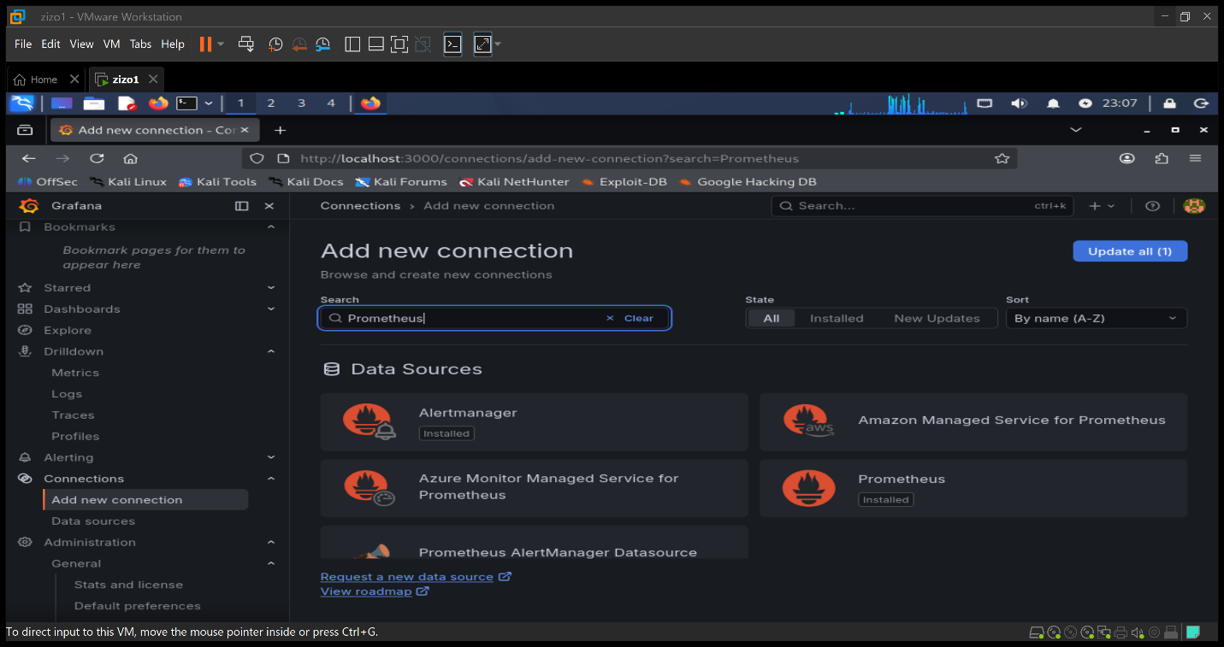
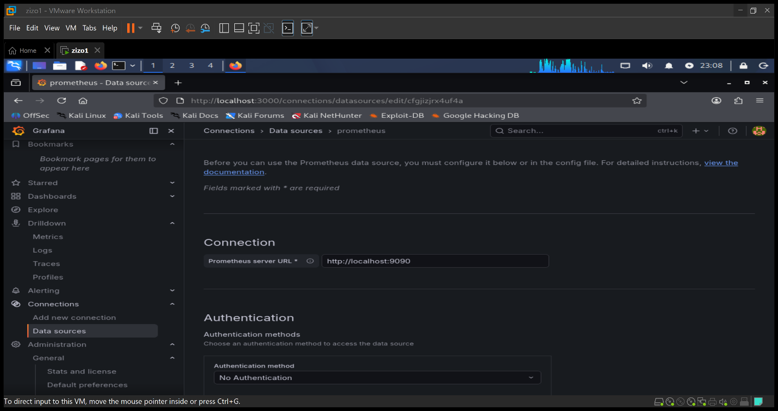
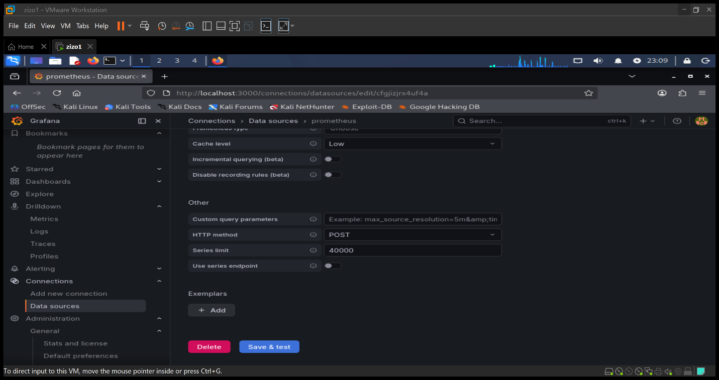
Save and test

After save go back to list and click on Dashboard
Create new dashboard
